**MODULE 4 Lesson 1:**

**Arithmetic & Geometric Sequences**

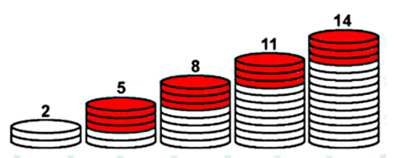

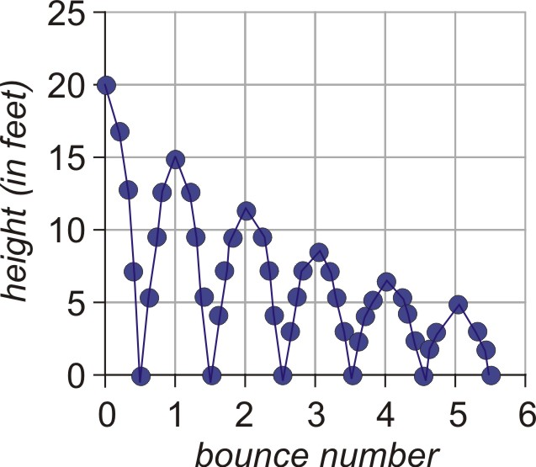

**9.1 Mathematical Patterns**

**A *sequence* is ……**

**Arithmetic (has a common difference, d) Geometric (has a common ratio, r)**

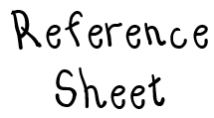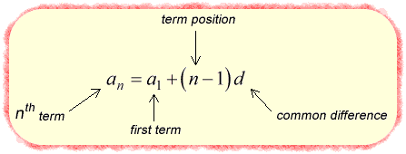**Explicit Formulas (equations) for Arithmetic and Geometric Sequences**

**Arithmetic Sequences**

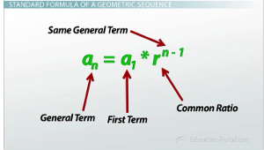

**Geometric Sequences**

**\*\*\* BOTH OF THESE ARE ON REFERENCE SHEET FOR REGENTS EXAM \*\*\***

**Writing Arithmetic/Geometric Sequences**

1) 4, 8, 12 , 16… 2) 8, 16, 32, 64…

an = a1 + (n-1)(d) an = a1(r)n-1

**Identify if the following is an Arithmetic or Geometric Sequence, state the common difference or ratio, then write an explicit formula for it.**

**a) 3, 7, 11, 15… b) 30, 25, 20, 15…**

**c) 3, 6, 12, 24… d) -5, -2, 1, 4…**

**e) 64, 16, 4, 1… f) -2, 4, -8, 16…**

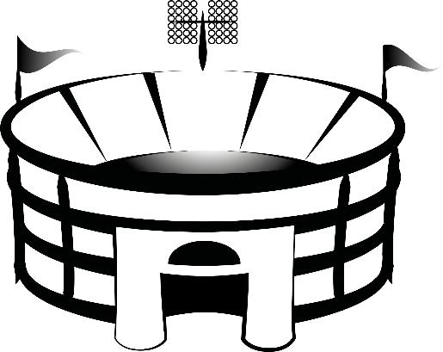**Ex. Row 1 in an arena contains 14 seats. Row 2 in the arena contains 17 seats.**

**Row 3 contains 20 seats. If this pattern continues,**

**how many seats will there be in Row 13?**

**Ex. When Johnny was a year old, his grandparents gave him $50. For each birthday, they increased their**

**previous gift by $50. If this pattern continued, how much would they give Johnny on his 18th birthday?**

**Recursive Sequences**

A ***recursive sequence*** is ……

**Example 1:** Find the first four terms of the sequence: $a_{1}=2$, $a_{n}=a_{n-1}+6$. Is this an example of an arithmetic or geometric sequence? Explain.

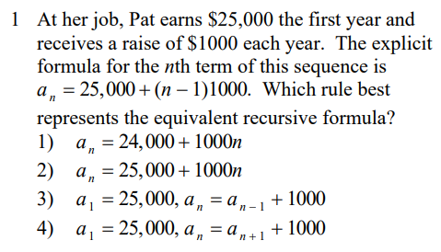**Regents Questions on Recursive Sequences…**

